**LAB-7**

**CE142**

**Aim: -Crud operations and more using hive query language.**

**1) Retrieve the data set.**

( <http://files.grouplens.org/datasets/movielens/ml-100k.zip> )

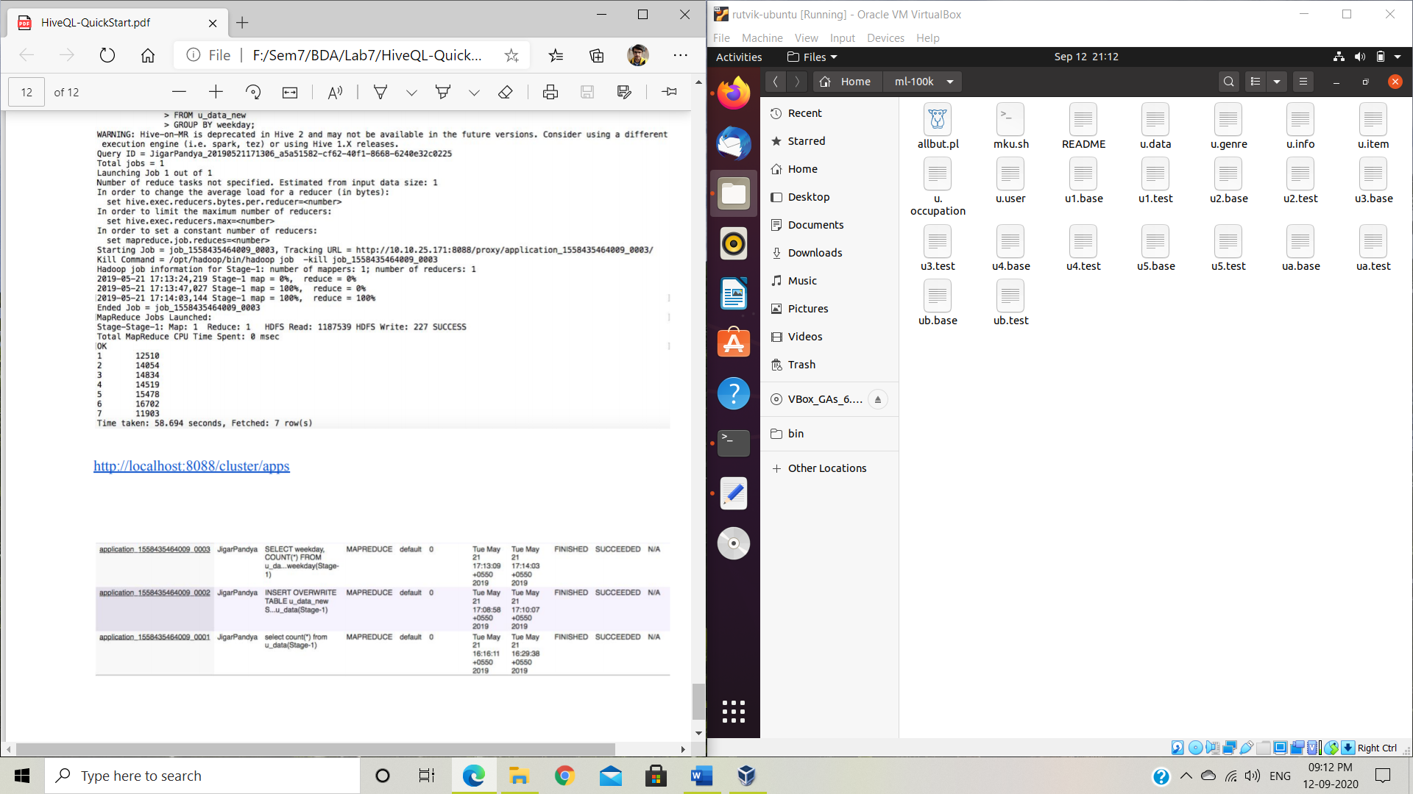Below is the screen shot of the content of ml-100k folder after unzipping it.

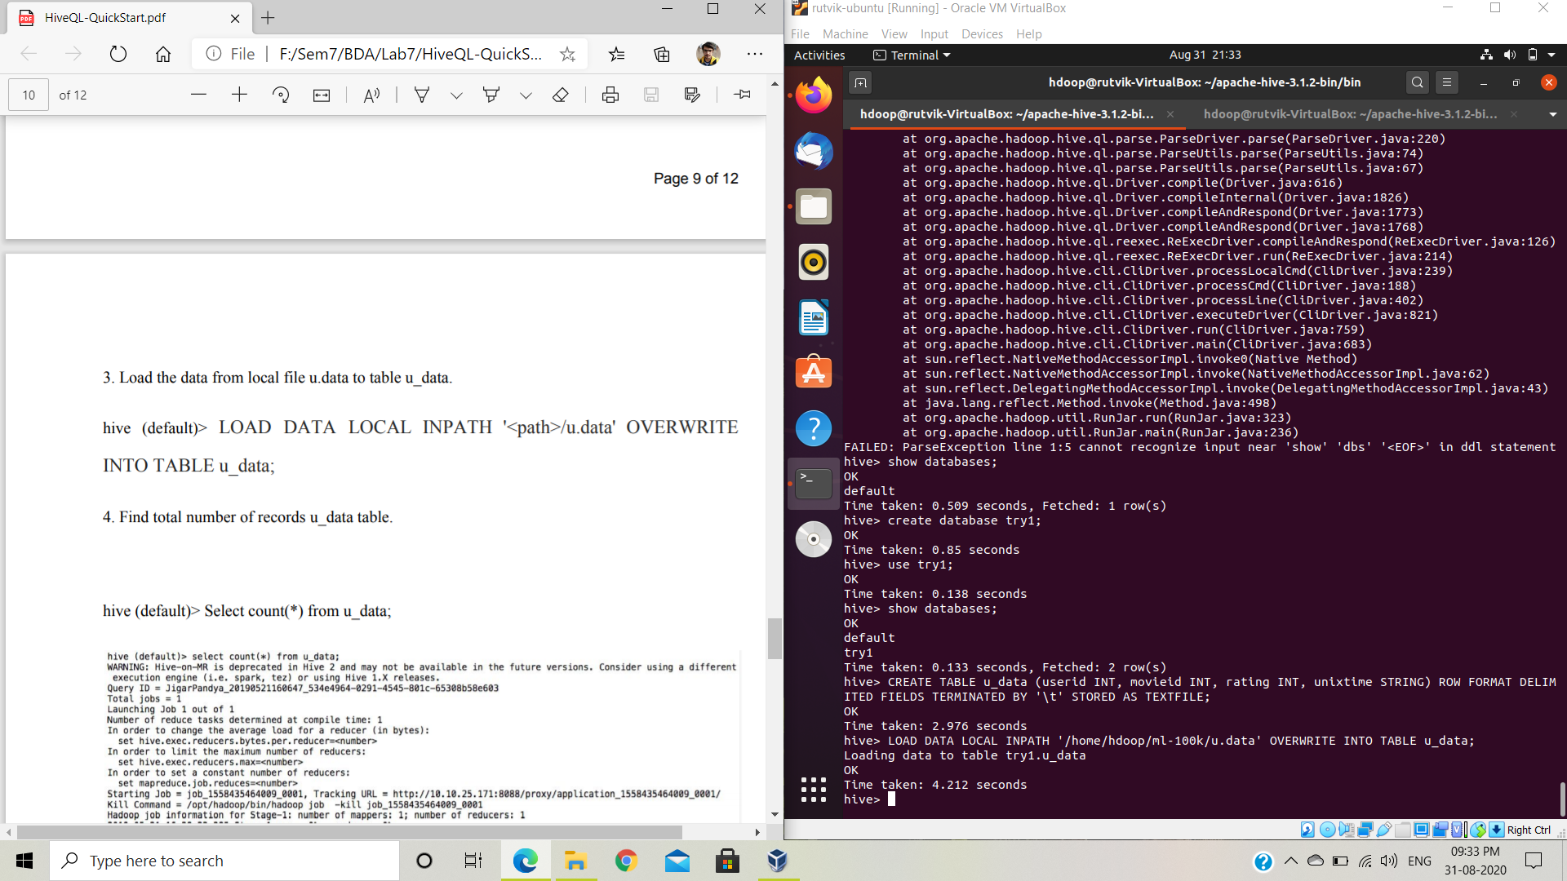**2) Run below HQL.**

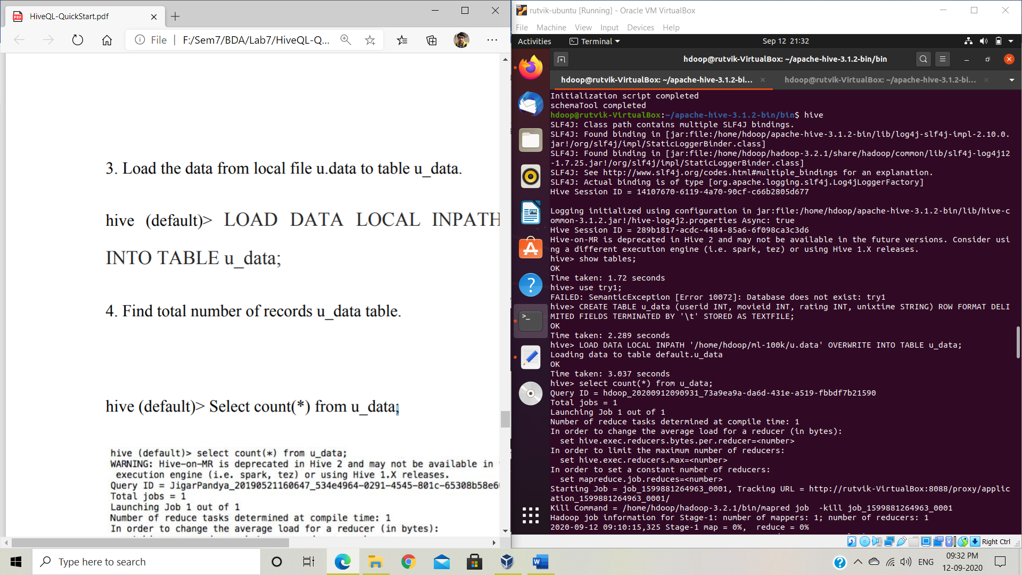**3) Load the data from local file u.data to table u_data.**

**4) Find total number of records u_data table.**

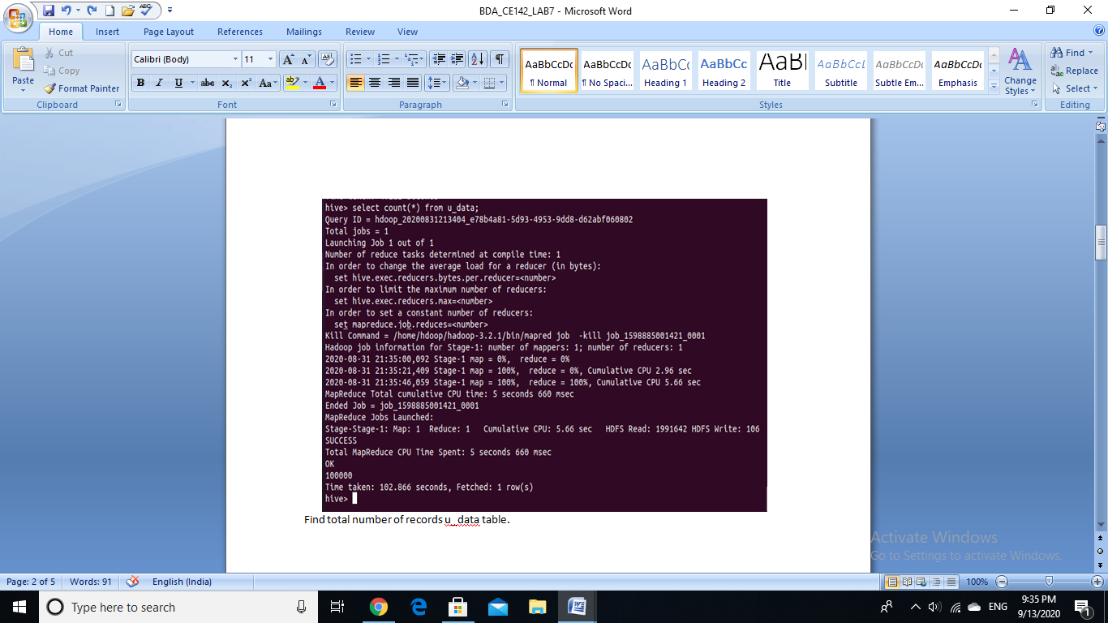

**5) Find weekday and corresponding count group by weekday.**

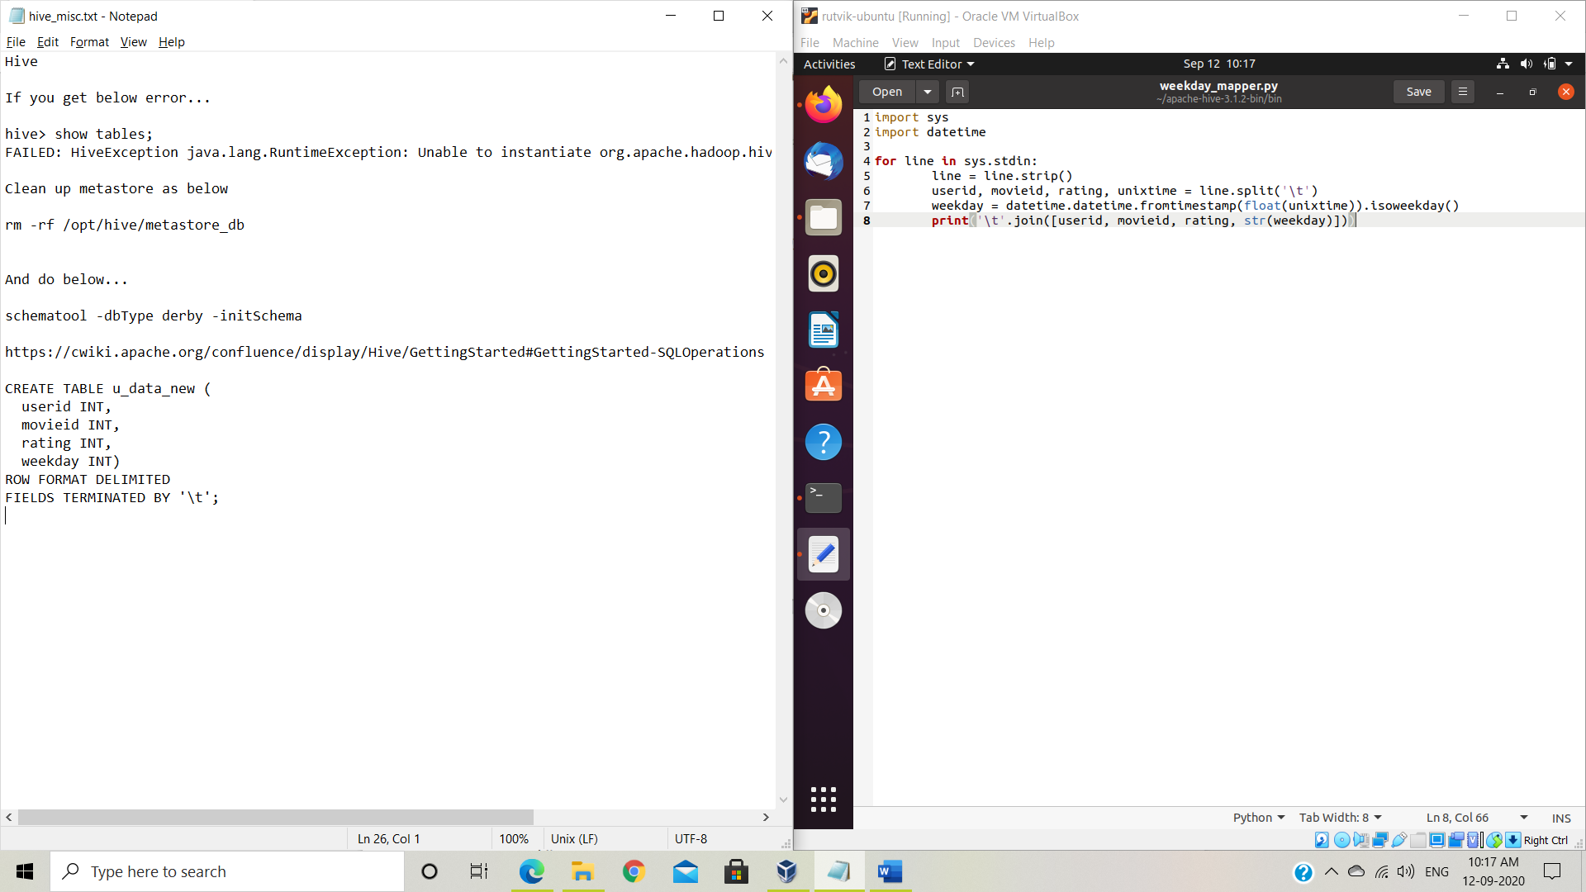Create weekday_mapper.py:

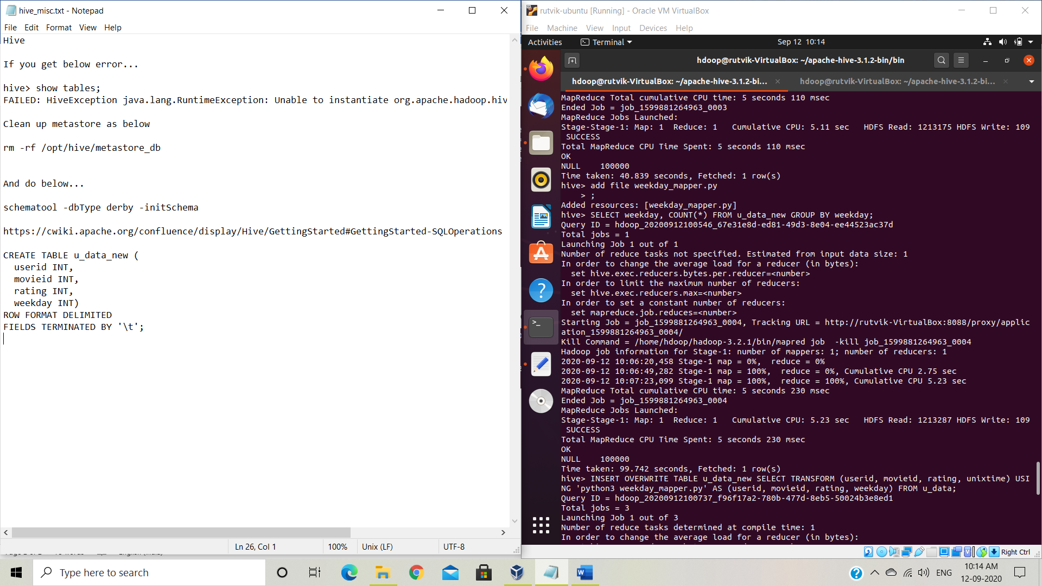Add file

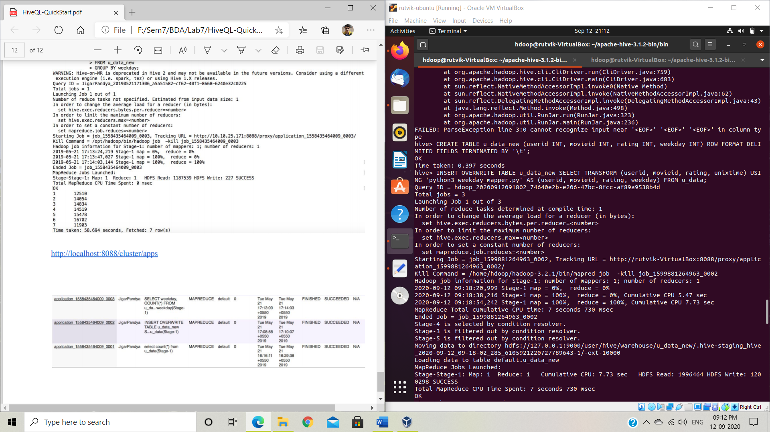Create table u_data_new

Insert data in u_data_new from u_data using weekday_mapper.py

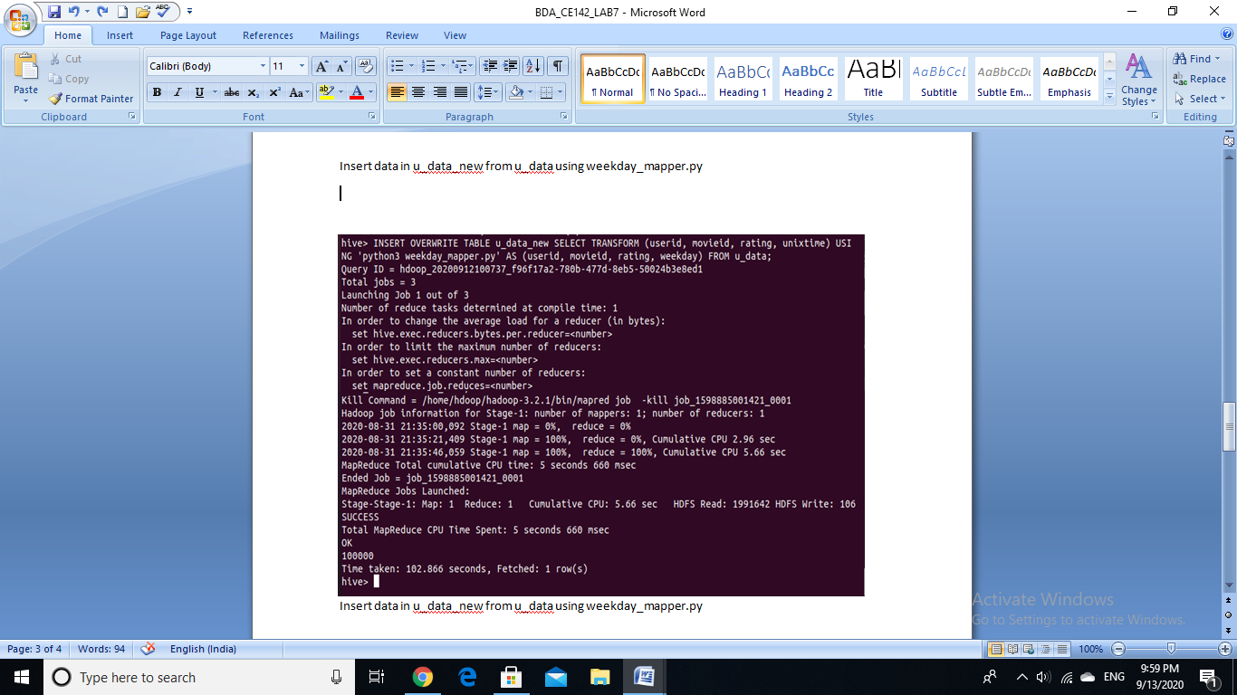

Query to get the final output:

